## PRODUCT PRICING

Product which are listed on the UB site, their pricing is coming based on the **product name and product size** from e-commerce site by using web service.

Service URL:

For Staging environment: We are using the below pricing URL- <http://ckstore.ckatesting.com/ItemPricing.asmx?wsdl/InitializePrices>

For Production environment: We are using the below pricing URL- <https://www.cliffkeen.com/ItemPricing.asmx?wsdl/InitializePrices>

Example:

[https://www.cliffkeen.com/Itempricing.asmx/InitializePrices?**ItemCode**=1CLOGO&CustomerId=138942&StoreId=1](https://www.cliffkeen.com/Itempricing.asmx/InitializePrices?ItemCode=1CLOGO&CustomerId=138942&StoreId=1)

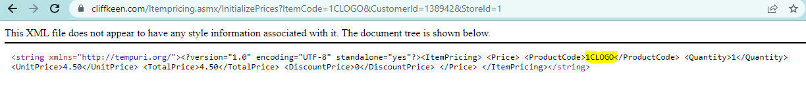

[https://www.cliffkeen.com/Itempricing.asmx/InitializePrices?**ItemCode**=3CLOGO&CustomerId=138942&StoreId=1](https://www.cliffkeen.com/Itempricing.asmx/InitializePrices?ItemCode=3CLOGO&CustomerId=138942&StoreId=1)



[https://www.cliffkeen.com/Itempricing.asmx/InitializePrices?**ItemCode**=6CLOGO&CustomerId=138942&StoreId=1](https://www.cliffkeen.com/Itempricing.asmx/InitializePrices?ItemCode=6CLOGO&CustomerId=138942&StoreId=1)

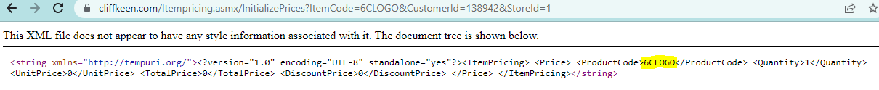

[https://www.cliffkeen.com/Itempricing.asmx/InitializePrices?**ItemCode**=1CLTR&CustomerId=138942&StoreId=1](https://www.cliffkeen.com/Itempricing.asmx/InitializePrices?ItemCode=1CLTR&CustomerId=138942&StoreId=1)

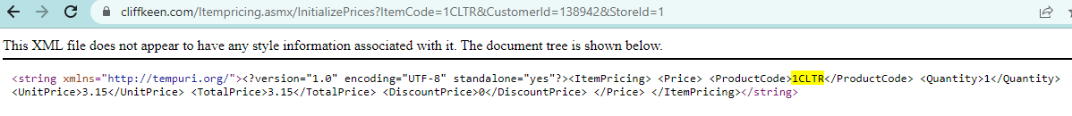

https://www.cliffkeen.com//addtockcahttps://www.cliffkeen.com/Itempricing.asmx/InitializePrices?ItemCode=6CLOGO&CustomerId=138942&StoreId=1

https://www.cliffkeen.com/Itempricing.asmx/InitializePrices?ItemCode=6CLOGO&CustomerId=138942&StoreId=1 s://www.cliffkeen.com/Itempricing.asmx/InitializePrices?ItemCode=6CLOGO&CustomerId=138942&StoreId=1

https://www.cliffkeen.com/Itempricing.asmx/InitializePrices?ItemCode=6CLOGO&CustomerId=138942&StoreId=1

https://www.cliffkeen.com/Itempricing.asmx/InitializePrices?ItemCode=6CLOGO&CustomerId=138942&StoreId=1https://www.cliffkeen.com/Itempricing.asmx/InitializePrices?ItemCode=6CLOGO&CustomerId=138942&StoreId=1

https://www.cliffkeen.com/Itempricing.asmx/InitializePrices?ItemCode=6CLOGO&CustomerId=138942&StoreId=1https://www.cliffkeen.com/Itempricing.asmx/InitializePrices?ItemCode=6CLOGO&CustomerId=138942&StoreId=1 PC~1&designId=12a6b366-5168-4f13-9c6b-6565c9829f5b~http%3A%2F%2Fub.cliffkeen.com%2FContent%2FcustomizedPngImg%2F03a340d5-cf1e-4a37-a2d9-de8aad5e4ec103a340d5-cf1e-4a37-de8aad5e4ec1sample.png&orig

https://www.cliffkeen.com/Itempricing.asmx/InitializePrices?ItemCode=6CLOGO&CustomerId=138942&StoreId=1

inalOrderNo=&_=1650966920876

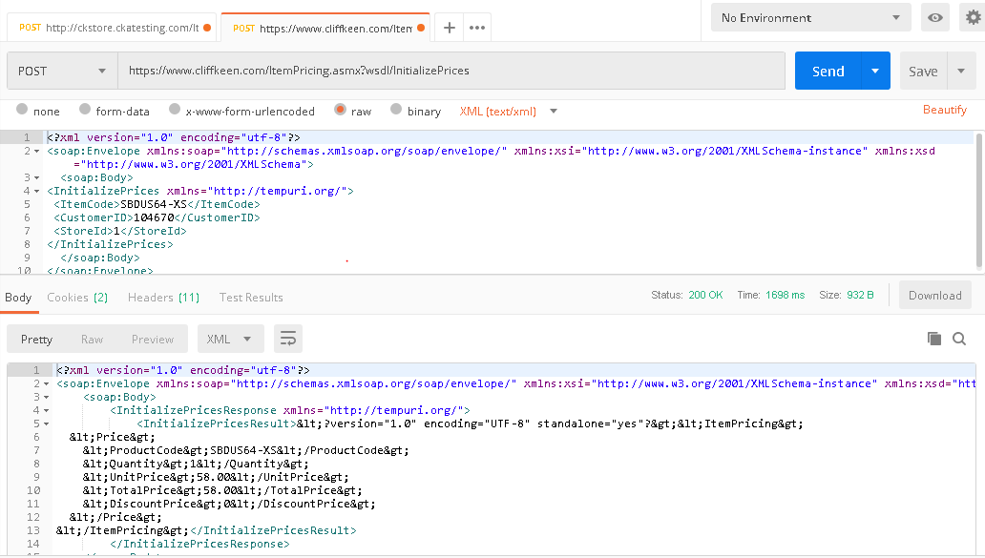

## ADD To CART:

“Add to cart” is the final step, this option will be shown at the end or after product customization, product pricing and sizing.

We must have login before going to “Add to cart and send to dealer” options, otherwise alert message will be displayed to the user to login first.

In add to cart, we are sending the customization product information like product Image, name, size and customize info (1CLRT,2 CLRT,1SUBLTR,2SUBLTR,1CLOGO,21CLOGO,31CLOGO etch) by using the asmx web service to the e-commerce site

Staging e-commerce asmx web service link: <http://ckstore.ckatesting.com/addtockcart.asmx/AddToCart>

Production e-commerce web service link: <https://www.cliffkeen.com/addtockcart.asmx/AddToCart>

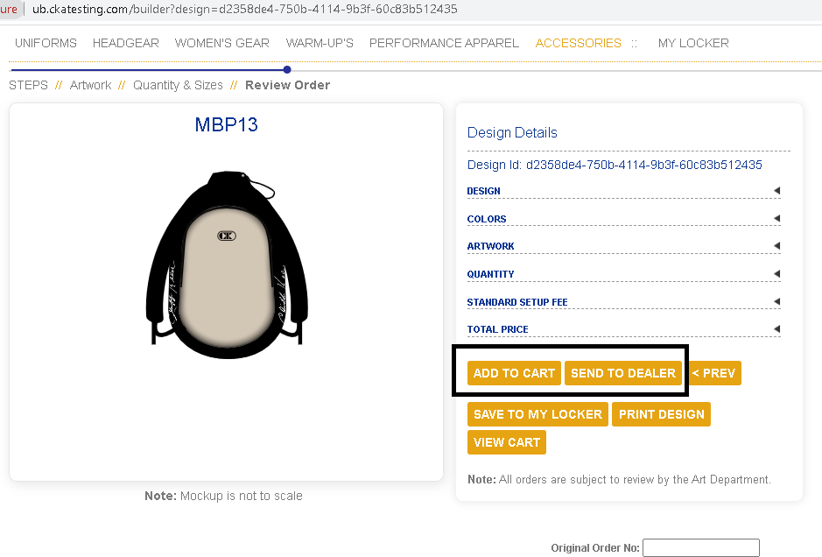

In send to dealer, we are sending email to the dealer with URL of UB site after clicking the URL, dealer can check all information related to the product.

Product Payload Example

Product name: MBP13

[https://www.cliffkeen.com//addtockcart.asmx/AddToCart?**callback**=jQuery1113019803286708693535_1650964580834&**lstChildProduct**=MBP13~9%2CSPPC~1&**designId**=303a68d9-4253-46b0-b0ea-2c684db926a2~http://ub.cliffkeen.com/Content/customizedPngImg/e12c42cf-33dd-4703-b95d-54bf378049e3e12c42cf-33dd-4703-b95d-54bf378049e3sample.png&**originalOrderNo**=&_=1650964580835](https://www.cliffkeen.com/addtockcart.asmx/AddToCart?callback=jQuery1113019803286708693535_1650964580834&lstChildProduct=MBP13~9%2CSPPC~1&designId=303a68d9-4253-46b0-b0ea-2c684db926a2~http://ub.cliffkeen.com/Content/customizedPngImg/e12c42cf-33dd-4703-b95d-54bf378049e3e12c42cf-33dd-4703-b95d-54bf378049e3sample.png&originalOrderNo=&_=1650964580835)

Product name: SBDUC59

[https://www.cliffkeen.com//addtockcart.asmx/AddToCart?**callback**=jQuery11130340775076021816_1650966920875&**lstChildProduct**=SBDUC59-XXXS~10%2CSUBLTR~20%2CSPPC~1&**designId**=12a6b366-5168-4f13-9c6b-6565c9829f5b~http%3A%2F%2Fub.cliffkeen.com%2FContent%2FcustomizedPngImg%2F03a340d5-cf1e-4a37-a2d9-de8aad5e4ec103a340d5-cf1e-4a37-a2d9-de8aad5e4ec1sample.png&**originalOrderNo**=&_=1650966920876](https://www.cliffkeen.com/addtockcart.asmx/AddToCart?callback=jQuery11130340775076021816_1650966920875&lstChildProduct=SBDUC59-XXXS~10%2CSUBLTR~20%2CSPPC~1&designId=12a6b366-5168-4f13-9c6b-6565c9829f5b~http%3A%2F%2Fub.cliffkeen.com%2FContent%2FcustomizedPngImg%2F03a340d5-cf1e-4a37-a2d9-de8aad5e4ec103a340d5-cf1e-4a37-a2d9-de8aad5e4ec1sample.png&originalOrderNo=&_=1650966920876)